**DH – Newsletter Pics and Info**

It’s been a busy several weeks for the Scorpions, and we’ve had lots to celebrate! The DH Student Council continued their yearly tradition of delivering Valentine candy grams between students and staff, and it was as fun as ever this year! In addition, we’ve also got a date for this year’s prom; May 10th, 2025. And we’re currently working on themes and extras. More info coming soon!

A proud day for parents and staff alike, on February 20th we celebrated our student’s awesome accomplishments at our academic assembly. Thank you to all who came out to recognize our kids’ accolades with us. And Scorpions, we are proud of you!

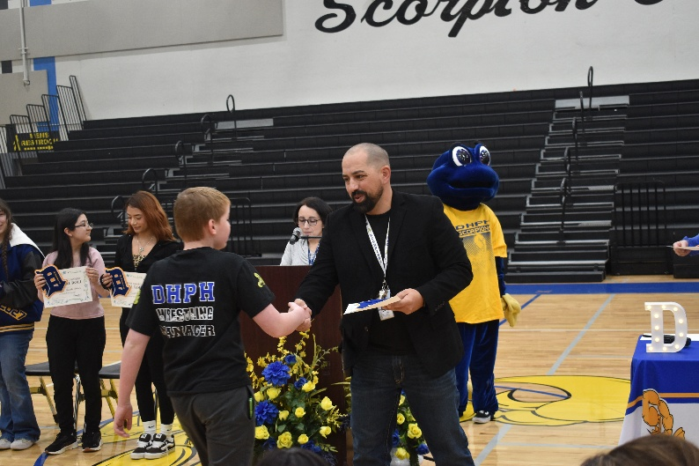

Speaking of celebrations, there was also a very exciting night of girls basketball where we sent our graduating student-athletes off with a home court win! Thank you, seniors, for an electrifying game and a career of memories!

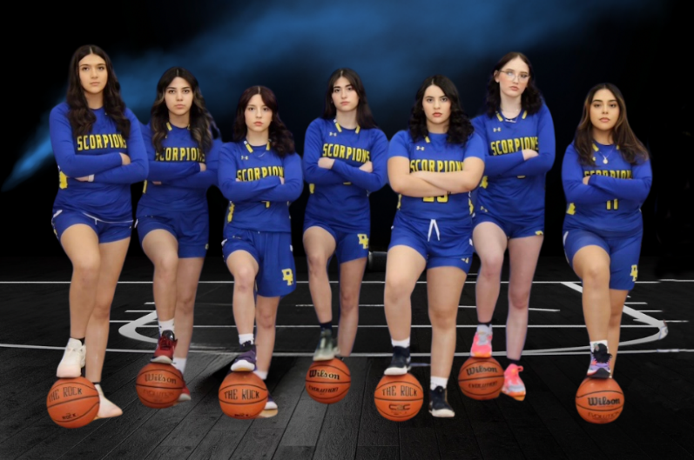

And finally, for the second year in a row coach Brandon Franklin and his team brought a state championship to DH! Students gathered together for a rally in the gym to share the pride and excitement. Congrats to all of our wrestlers and coaches for this amazing feat. And congratulations especially to our 113-pound champion, AJ Jaramillo!

