STING Presents
Scorpion Tales
Published Monthly | December, 2024 | Issue 5 vol. 2
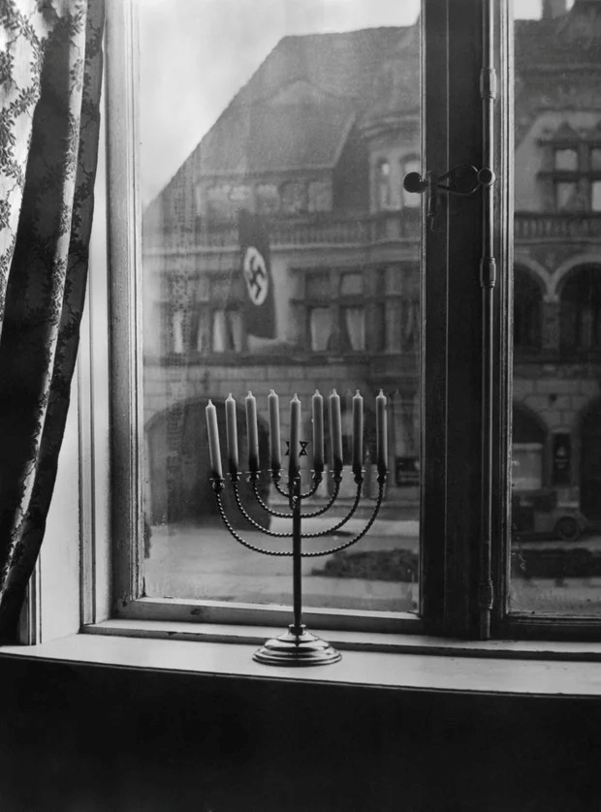

“Never Forget” | “Shine, Shine, Shine! Let Hanukkah Shine!” | Photo by Rachael Posner/ with permission.
Con’t
We would talk, mostly he would talk, and he told me of things I could not fathom. He spoke of atrocities he had witnessed and endured. His life would be considered remarkable and miraculous, but he considers it an affront.
We didn’t understand survivors’ guilt at that time, but he suffered from it just the same. He questioned why he survived the flames, the gas, the bullets. Why did he alone emerge from the place that had taken all his family away. Why had God chosen him to walk into this harsh world.? “If God lived on Earth, his house would have broken windows” he would say, chuckling as he sipped his whiskey.
He was at the Nuremburg trials, as an interviewed, but uncalled witness. He was in Israel for the trial of Adolf Eichman, again interviewed and deposed, but never called. He had to share his pain and hurt with a world of strangers, most of whom could not comprehend the evil he had witnessed and been subjected to. During the trial in Israel, he was scorned for not fighting back, for not rebelling as the Jews had at Masada. Then after the trial, after all the testimony, he was held as a hero. “A hero? Me? No.” the sip of whiskey passing his lips, “No, not me.”
He was a remarkable man, a scholar and teacher of great worth and merit. He rebuilt his life after Bergen-Belsen, after Auschwitz. He settled in Kentucky and lead a synagogue thru trying times. Here in his adopted homeland, he faced racism, hatred, burning crosses. He spoke that God was punishing him for surviving, that was why America was sometimes so harsh.
My friend passed away peacefully in his home, with his new family by his side. He sang his final Kaddish and closed his eyes.
I wish him well, and I miss him, still.
Rest well:
Rabbi Dr. Chiam Gettleman 1900-2000
“We teach every day; we walk every mile. We pay the debt we owe.”

Hatred Across the Street and Rebellion Behind the Door  Neon Gonzales, Sami Ortman, Natalie Munoz, and Carlos Saen  A photograph was taken during the time of Nazi-Germany. This photo depicted a Nazi swastika flag hanging from a home outside, while inside, across the street, stood a Jewish Hanukkah menorah. Both are separated by only glass, and a street. The photo poetically conveys a strong sense of rebellion against a hateful group. Although not openly protesting, the Hanukkah menorah decorating the home’s window is defiant enough. It shows that despite the terror and the fear that is being inflicted, in silence there will always be a voice to speak out against injustice. | Sometimes, “the Old man” must write.  Troy McSpadden, JCL, STD, DD  He was stronger than his frail frame would belay. His semi balding, shaggy silver gray covered head showed his age. His wisdom was second to none, as his theological background was scholastically impeccable. His only vice, if you could call it that, was a single glass of beer each day. He was a fine, simple, man.  The only time this changed was on certain anniversaries. There were dates he could not forget, and his simple glass of beer would turn to multiple glasses of whiskey, as if the liquor was required to open the chambers in his mind to which he relegated those memories. His wife, his children. Those memories he stored away. Far away from the happy stories he delivered from the pulpit to his congregation on the Sabbath and the High Holy Days.  We didn’t talk about the number on his arm, A5861, still burned in this author’s memory, we didn’t discuss things like that in polite company. The whiskey nights, though, were different.
December, 2024 | Scorpion Tales |  |  | Issue 5, Vol.2
The Little Drummer Boy  Alizah and Annalyse  Staff Writers  The Little drummer boy, a stop motion animated TV show, debuted on December 19th, 1968, to Canadian audiences, and 4 days later to American ones. The story follows Aaron, who received a drum on his birthday. Aaron discovers that his drumming makes the animals on his family farm dance. As Aaron plays, bandits come and attack the farm, leaving him alone in the world. Soon his grief is such that he develops a hatred for all humankind. While wondering, Aaron is kidnapped and forced to join a traveling group of players. He lets them know that they are thieves and bandits, and the leader of the caravan berates him and after the dressing down, continues to travel. The caravan’s camel is sickly and weak, and completely worn out from trying to chase the Magi. Attempting to sell the old camel, Aaron opts to keep him, naming him Joshua. The small group runs toward Bethlehem, following the star, to discover the manger scene. Following the lyrics from “Carol of the drum” Aaron plays for Him, Aaron and his drum. |  |  | Wrestling: The true Winter Sport  High school wrestling is a dynamic and intense sport that combines strength, technique, and strategy. Wrestlers compete in various weight classes, ensuring fair and balanced matches. The Sport emphasizes discipline, physical fitness, and mental toughness. Wrestlers train rigorously, learning various holds, takedowns, and escapes. Matches are typically fast paced and require quick thinking and adaptability. High school wrestling not only builds athletic skills but also fosters teamwork, sportsmanship, and personal growth.  Wanted: People interested in rewarding hard work and supporting the experience of a lifetime! Coach Franklin is looking for you! Support Scorpion Wrestling! Champions are made in the Winter!
(Submitted with no byline)
Little children gaze in awe as snowflakes gently fall from the sky, transforming the world into a winter wonderland. Their eyes sparkle with wonder and delight, tiny hands reaching out to catch the delicate flakes. Laughter fills the air as they experience the magic of snow for the first time.
"Feliz Navidad" was written and first recorded in 1970 by Puerto Rican singer-songwriter José Feliciano  . The song has since become a beloved Christmas classic, known for its simple, heartfelt lyrics and festive melody. |  | Christmas Time With Charlie Brown, A Night of Joy and Warmth  Neon Gonzales and Sami Ortman  Charlie Brown movies have become a tradition for families across the country. The movies are very nostalgic, giving off a warm feeling, especially Charlie Brown’s Christmas. This film brings old memories out of the attic, sending adults back to their childhood, even for just a moment. The movie fixes the main problem in a human way rather than having Santa save the day. It takes a more refreshing spin on the “Christmas Crisis” narrative that is popular with a lot of Christmas time movies. The movie is entertaining for adults, as well as children, having a wide range of ages watching the events of the film unfold. A Christmas miracle indeed, starting a tradition that lasts for generations.
Christmas lights originated in the 17th century with candles on trees. Electric lights, introduced by Thomas Edison in the 1880s, revolutionized holiday decorations.  Wanted: People to support Coach Guerrero in his belief that BASKETBALL is the SUPREME WINTER SPORT while cheering on his Scorpion Cagers!  Scorpion Basketball  The rage in the Cage! |  |  | Make sure you are keeping up on your Service hours! Check with Mr. McBee or  Ms. Padilla!  Scorpion Tales is a wholly owned, non-profit, digital publication of Chavez Hurta Preparatory Academy/Delores Huerta Preparatory High school. All rights reserved.  Publisher: Fred Segura  Publisher: Bryan Weimer
Page 2

December 2024 | Scorpion Tales |  |  | Issue #5, Vol. 2


This Photo by Unknown Author is licensed under CC BY/AP

Inside Kyla and cat’s collective mind  Kyla Melton & Catriona Baxin-Vigil  Staff Columnists  Thanksgiving is a holiday where people give grace and express their thanks towards their family, friends and blessings. This holiday is usually accompanied by plenty of food, so individuals can feast over their thankfulness.  The food is to die for, if it is prepared and cooked well, that must be what some food-intolerant individuals are trying to convince themselves of after this year's holiday.  Perhaps the idea of declining food made by beloved family and friends is something that not everyone can manage. Thanksgiving, the holiday of grace, but some are too thankful, eating food that they should not.  A day of food is not worth the physical faults that may occur, especially if you’re more sensitive than most, or even worse, have an autoimmune disease. The gift of pain results from giving into food, giving into family. Hopefully, it was worth it,  we plead. |  | Every year, on Christmas Eve, my mom, my brother, my sister, and I have this tradition that makes the holiday feel extra special. It’s nothing fancy, but it’s one of those things I can’t imagine Christmas without.  The whole day feels like a build-up to our tradition. In the afternoon, the four of us bake cookies together. My mom is in charge of organizing everything because if she didn’t, it would be pure chaos. My sister and I always take over the decorating, and we get super competitive about who can make the best-looking gingerbread person. Meanwhile, my little brother is in charge of “quality control,” which basically means he eats half of the frosting before it even makes it onto the cookies. Somehow, we always end up with trays of cookies that look completely random, but they taste amazing, so no one cares.  After baking, we all change into our matching Christmas pajamas. Yes, even my brother, although he acts like it’s the most embarrassing thing ever. My mom picks a new design every year—this time, it’s red ones with little snowmen on them. We take a bunch of goofy pictures in front of the Christmas tree, and it’s one of those rare times when no one is arguing or rolling their eyes.  Next, we make hot chocolate. My mom has this thing about doing it from scratch, so she melts chocolate on the stove and adds milk. My sister always tries to add marshmallows and whipped cream, which turns her mug into a sticky mess. My brother just dumps a mountain of whipped cream on his and pretends it’s a science experiment. | Then comes the best part: movie time. We all pile onto the couch with our mugs and a plate of cookies and watch Home Alone. We’ve been watching it every year for as long as I can remember, so it’s officially part of the tradition. My brother likes to act out the traps Kevin sets for the burglars, which is hilarious and kind of terrifying at the same time. My sister and I quote the funny lines, and my mom just laughs at how ridiculous we all are.  After the movie, we turn off all the lights except for the Christmas tree.  The house gets so quiet, and we just sit there for a while, staring at the glowing lights. Sometimes, we talk about our favorite Christmas memories, and other times, we just sit and enjoy the moment. My mom always reminds us that these little traditions are what make the holidays special, and I think she’s right.  Before bed, we set out a plate of cookies for Santa and a glass of milk. Even though we’re all old enough to know Santa’s not real, it’s still fun to keep the tradition alive. My brother always sneaks an extra cookie onto the plate “just in case Santa’s really hungry,” which makes my mom laugh every time.  Christmas isn’t about the presents or the big dinner—it’s about spending time together and making memories. No matter how much we grow up or how busy life gets, I hope we never stop doing this. It’s more than just a tradition—it’s a reminder that, at the end of the day, we’re a family, and that’s what really matters.
Who Wins in the Battle of the Best winter sport?  Is it Coach Franklin and his mat-men?  Is it Coach Guerrero and his rowdy Cagers?  Find out in Scorpion Tales! |  | (Keeping this one up for educational purposes. Editor)  Dear Sting: Why are all the staff giving us a hard time about being in the bathrooms? We ain’t hurting nothing, and we got nowhere else to hang and chill. What’s the issue? Unsigned  Dear Unsigned: I think I’m gonna let Mr. McSpadden handle this one.  Thanks, Sting, I figure something has to be attracting 10 plus individuals into an area that has the capacity of 2 areas to void bladders. My question is why? Are you unaware that people utilize this area to excrete human waste? There must be better places to hang out. | Got a question, a burning desire? Hit us up! Need some advice?  Dearsting14@gmail.com
Pg. 3

