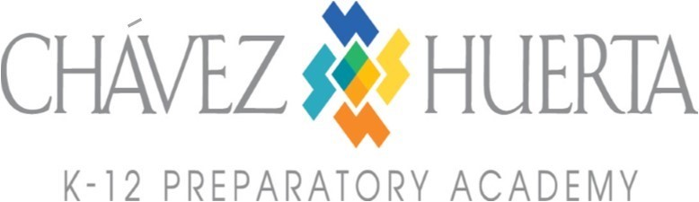

Official Meeting Notice
Wednesday, May 15, 2024
Open Board Seat Interviews 5:45pm – 7:45pm

The following individuals will be interviewed for the open position CHPA Board of Director’s Seat.
The applicant names are listed in no particular order.

Victor Vialpando
Kathleen Martinez
Dara Harris
Cynthia Ayala-Cooper

