February | Scorpion Tales  It was a dark and stormy night… |  |  |  |  |  |  |  | Issue #7
New Experiences  Danea Sisneros  I’ve been able to experience new things in life that I have not seen before now. My friends and myself have gotten super close within the past 2 months, which makes me happier than I have been in a while. I enjoy spending my time among my friends, and they make it easier to keep my focus on Graduation, my GPA, and my future.  -----------------------------------------------------------  What I like to watch  My (current) favorite show  Delisia Chavez  My favorite show right now is “Abbott Elementary”. The show is about the teaching staff of the named school, and the funny and relatable situations in which they find themselves. My favorite characters are the Principal, Ava, and one of the teachers Lisa. Both are likable, funny and Ava is so relatable! |  |  |  | 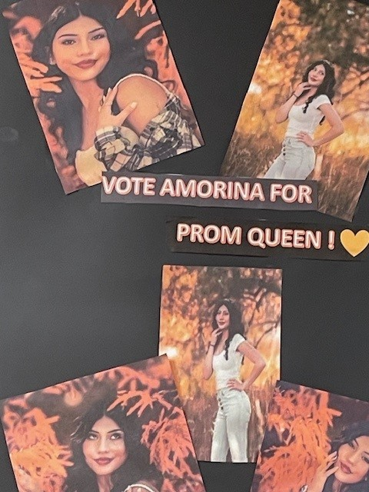  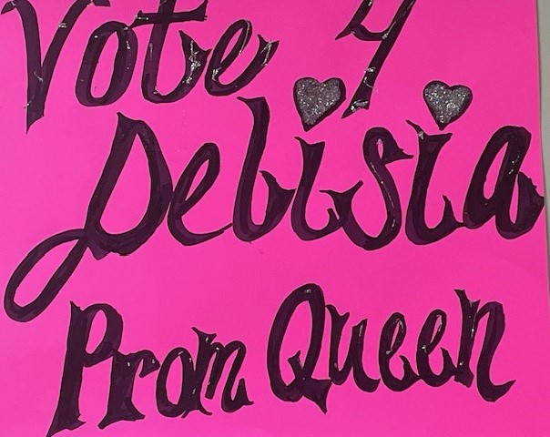 Seen around campus!
 |  |  |  | Scorpion Tales Staff photos Rights reserved
 |  |  |  | Get with Mr. McBee and Ms. Padilla and make sure your Community Service hours are completed!
 |  |  |  | We were able to see the following nominees for king and queen: Alicia, Kate, Aries, Zariah, Marcos, Romeo, Jonah, Cameron. A lot of tension among the audience waiting for the moment of the winners, waiting if the couples will be the winners or someone else. In the end, Aries was our prom queen, and Marcos our king, it was not a couple but in the same way the public was left with a lot of emotion and enthusiasm. It was a magical, fun, and surprising night. |  |  |  | Mars is out of this world!  Jorge Vega, writer  Mars, the red planet, has captivated the human imagination for centuries. With its rust-colored terrain and elusive secrets, Mars stands as a beacon of exploration and possibility. Ranging from scientific missions to travelling adventures, Mars continues to inspire curiosity and the quest for understanding, of our celestial neighbor.
A Blast from the past by Prom queen Candidate Jormary Figueroa-Rivera
Homecoming is something many look forward to as the new school year begins. Many are excited about this, and others simply don't pay much attention to it, as some say, "it's just a dance." Last Saturday we were able to witness it, some will say that it was boring and others that it was great, but people will always have different opinions or perspectives about something.
Scorpion Tales |  |  | The Staff gets smaller |  |  |  | Do We do the Dew?
Is a digital production of the Journalism class of DHPH |  |  | But remains Mighty! |  |  |  | What’s your favorite soft Drink?
This Publication is the wholly owned intellectual property of CHPA with all rights reserved.  Vicki Potter, Publisher |  |  | Editor: Romeo Martinez  Staff editor: Chloe Duran  The 6th Period Mighty Journalism fills in the rest! |  |  |  | Enquiring Scorpions want to know!  Contact your favorite Journalist and let them know!
 |  |  |  |  | Page 1

February | Scorpion Tales |  |  |  |  |  | Issue #7
From the desk of the Scorpion Tales Historical Research Group
Wanna take a ride?  The Research Group  The earliest UFO sighting in recorded history was in 1450 B.C.E. After conquering the ancient Nubian city of Napata, Thutmose III had a stele (a stone or wooden slab) erected at the Temple of Amun, beneath the cobra-shaped Jebel Barkal outcropping.] The stele describes how "a star came down" to set fire to Thutmose's adversaries. The incident has been cited by the purported Tulli Papyrus, considered by Edward Condon to be a likely fraud. In the Hebrew Bible is the story of Elijah: “And it came to pass, as they still went on, and talked, that, behold, there appeared a chariot of fire, and horses of fire, which parted them both asunder; and Elijah went up by a whirlwind into heaven”. (2Kings 2:11NASB 1998) |  |  | We are surrounded by numerous events that focus on this unexplained phenomenon, yet many who claim these very same experiences are considered crackpots…  Until Now…  The United States Navy has released cockpit video of F-18s chasing unidentified or unidentifiable craft. The released videos show the craft flying in ways that defy Newtonian physics, diving underwater to resurface again, and streaking into the sky only to disappear from camera and radar. The release of these videos has also coined a new phrase “unidentified anomalous phenomenon” or UAP. The change in nomenclature is so that discussions about these sightings are not considered “less reputable by association with the term UFO.” (Congressional Record, FOIA 2/02/24) |  |  | So, we have come to a point where we must now accept (as our Government has) that there are things that cannot be explained. Suddenly, all the evidence that has been produced over the years, demands reevaluation. We are indeed in for a ride!
Stranger Things

Chloe Duran, Staff editor

I’ve been watching a show called Stranger Things that came out in 2016. The show is produced by Monkey Massacre Productions and 21 Laps Entertainment; it was released on Netflix following 4 seasons. They hope to release Season 5 soon; they have officially begun production on January 8, 2024. The show has many interesting things about it, it’s based off a game called Dungeons & Dragons and drawing inspiration from the Duffer Brothers own childhood experiences.

It’s all happening at the Zoo!
Delisia Chavez, Feature writer

On the 19th of February, my friends Chloe, Danea and myself journeyed to the Pueblo Zoo. We spent the first part of the visit in the Gift shop, and had pleasant conversations with the employees and volunteers. We left the gift shop and began our walk around the Zoo. We got to view several types of monkeys, Red Pandas, snakes, otters, a lion, camels, goats, turkeys, (in addition to several other types of birds) bunnies, lizards, armadillos, turtles, fish and meercats. My favorite part was watching the monkeys with a zookeeper, telling them to do tricks, it was so cool and cute.
Graphic DHPH/CHPA all rights reserved
Fabulous well wishing, including everyone at the Academies, saw the Scorpion Wrestling team off to the Colorado State tournament. Represented by 4 amazing wrestlers, the Scorpions fought hard and advanced well. At 106 pounds, Miguel Franco brought home the State title! |  | “Wrestlers of the highest caliber in the state were there. We were competitive, and showcased our talents.” Relayed a very happy Coach Franklin.  Hard work and dedication paid off for Miguel and all our DHPH wrestlers!  Congratulations!
 |  |  |  | Page 2

